R STUDIO

data=fread("C:/Users/user/Downloads/salaries.csv")

head(data)

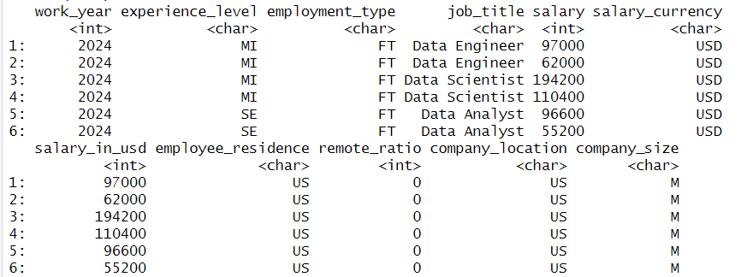

data1=select(data,job_title)

head(data1)

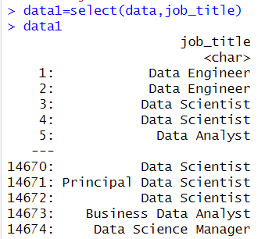

data2=select(data,job_title,salary)

head(data2)

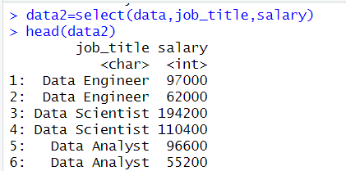

fil=filter(data,salary%in%c(98000))

fil

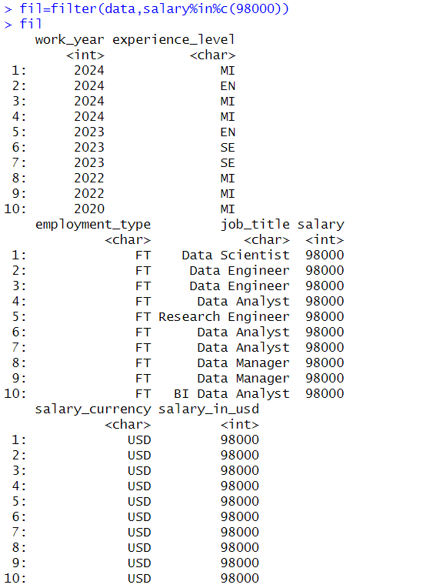

fil2=filter(data,salary %in% c("90000","110000"))

fil2

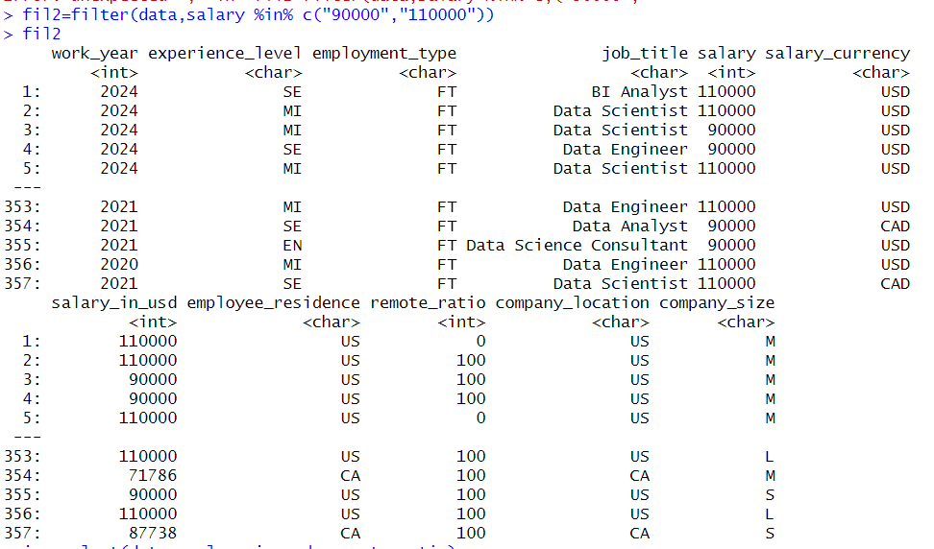

ign=select(data,-salary_in_usd,-remote_ratio)

head(ign)

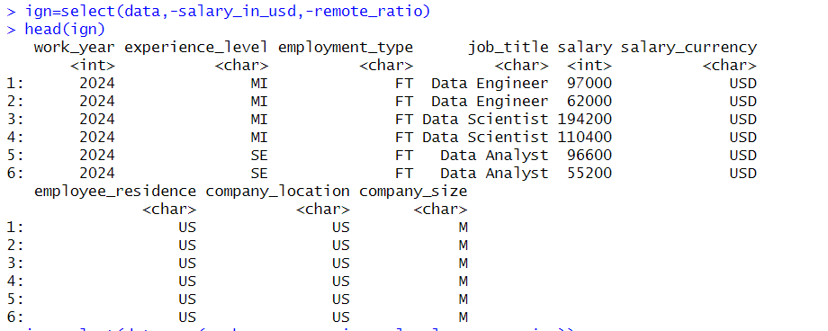

iog=select(data, -c(work_year,experience_level,company_size))

head(iog)

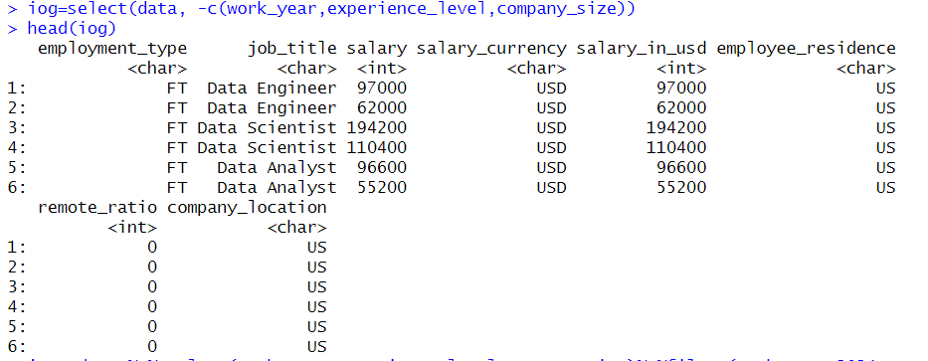

iop= data %>% select(work_year,experience_level,company_size)%>%filter(work_year>2024,company_size<'M')

head(iop)



iop1=data%>% select(salary_in_usd,salary)%>%mutate(salary*salary_in_usd)

head(iop1)

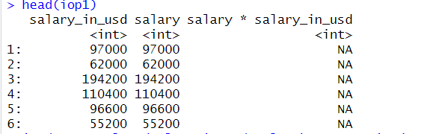

io=data%>%select(salary_in_usd,salary)%>%summarize(mean=mean(salary))

io

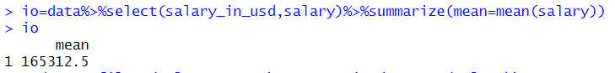

x=data%>%filter(salary==62000)%>%summarize(sum=sum(salary))

x

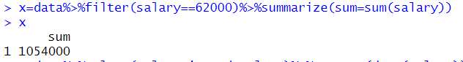

y=data%>%select(salary_in_usd,salary)%>%arrange(desc(salary))

y

